CURRICULUM VITAE 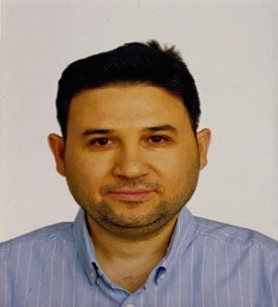
Şenol Sarı

Education

DEGREES | INSTITUTION | DATE | MAJOR FIELD
PhD. | Pamukkale University | 2025-Ongoing | English Language Teaching
M.A. | Yeditepe University | 2024 | English Language Teaching
B.A. | Selçuk University | 2007 | English Language Teaching

Academic experience

September 2024 – to date Lecturer of English, School of Foreign Languages, Antalya Bilim University, Antalya
July 2019 – July 2024 English Teacher, Antalya Bilim College
August 2018 – June 2020 Lecturer of English, School of Foreign Languages, Antalya Bilim University, Antalya
September 2009 – August 2018 English Language Instructor, Turkish Air Force Command
September 2007 – August 2009 English Teacher, Mimar Sinan İzzet Baysal Anatolian Vocational High School

Certifications

- Delta Module 1: Understanding Language, Methodology, and Resources for Teaching English
- ICAO (International Civil Aviation Organization) Course for Aviation English Rater

Service activities

- Organized and supervised Scrabble tournaments to enhance vocabulary and strategic thinking skills.
- Led and coordinated English Debate Club activities at various levels within the Air Force Academy and other educational institutions.
- Participated in and mentored Model United Nations (MUN) conferences organized by universities to develop students’ diplomacy and public speaking skills.
- Contributed to and supported projects funded by TÜBİTAK (The Scientific and Technological Research Council of Turkey), promoting scientific inquiry and student research.

Conferences presented at

- Enhancing Authorial Presence and Reader Engagement in Academic Writing, the 9th International Symposium of Limitless Education and Research (2025)
- From Neutrality to Transparency: Navigating Subjectivity in the Discussion Sections of Research Articles, 13th Annual International Conference on Humanities & Arts in a Global World, 3-6 January 2026, Athens, Greece (accepted for presentation)

Conferences attended

- 9th International Symposium of Limitless Education and Research (2025)
- Antalya Bilim University 6th ELT Conference
- Antalya Bilim University 8th ELT Conference
- Antalya Bilim University 9th ELT Conference
- Turkish Air Force Language School ELT Conference (2016-2018)
- Turkish Military Academy ELT Conference (2018)
- Turkish Air Force Academy ELT Conference (2017)
- Kuleli ELT Conference (2014)
- Işıklar Air Force High School ELT Conference (2009-2016)
Conference Proceedings

- Deveci, T., and Sarı, Ş. (2025). Enhancing authorial presence and reader engagement in academic writing. In the Proceedings of the 9th International Symposium of Limitless Education and Research Conference (p. 51). SEAD.

Review Activities

- Language editor for Journal of Limitless Education and Research (J-LER)

