Batuhan GÜRS, Faculty Member (Research Assistant)
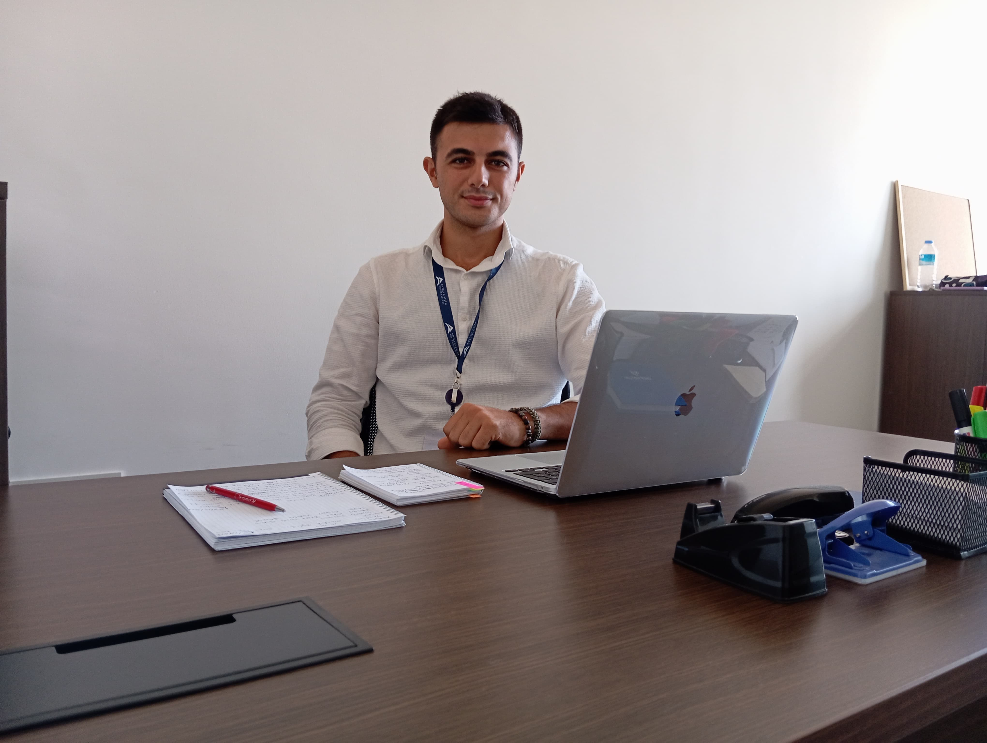
Research Assistant
Antalya Bilim University
Tourism Faculty

E-mail: Batuhan.gurs@antalya.edu.tr
Office no: B2-52

Education

- Bachelor- Gazi University, Tourism Faculty, Gastronomy and culinary arts, 2017-2021
- Master- Bolu Abant İzzet Baysal University, Tourism Faculty, Gastronomy and culinary arts 2022- Continues

Academic Employment

- Faculty Member (Research Assistant), Antalya Bilim University, Tourism Faculty, Gastronomy and culinary arts, 2023- Continues

Professional Employment

- FACULTY MEMBER (RESEARCH ASSİSTANT) Antalya Bilim University Tourism Faculty, Gastronomy and culinary arts, 2023- Continues
- DEMİ-CHEF HUQQA- 31/05/2022 – 30/08/2022 Muğla, Türkiye
- GASTRONOMİ VE MUTFAK SANATLARI ZORUNLU STAJ Point otel 100. yıl- 05/06/2019 – 25/08/2019 Ankara, Türkiye
- DEMİ-CHEF DİAMOND PREMİUM HOTEL & SPA- 05/06/2018 – 25/08/2018 Antalya, Türkiye
- VOCATİONAL HİGH SCHOOL COMPULSORY SUMMER İNTERNSHİP Swiss otel Kızılcahamam- 01/04/2016 – 26/08/2016 Ankara, Türkiye
- VOCATİONAL HİGH SCHOOL COMPULSORY SUMMER İNTERNSHİP Bernstein Acamed Resort- 05/06/2015 – 29/09/2015 Nienburg (Saale), Germany
Support Courses/Teaching

- Gast 201.1- Mutfak Teknolojisine Giriş
- Gms 2001.1- Mutfak Uygulamaları I
- Gast 301.1- Mutfak Teknolojileri II
- Gast 337.1- Uzak Doğu Mutfağı
- Gast 403.1- Mutfak Teknolojileri IV

Research Interests
- Kitchen trends
- Cultivation of seasonal and local products.
- Molecular gastronomy
- Technology and kitchen
- Food and beverage businesses management
- Food science

Languages
- Turkish
- English

