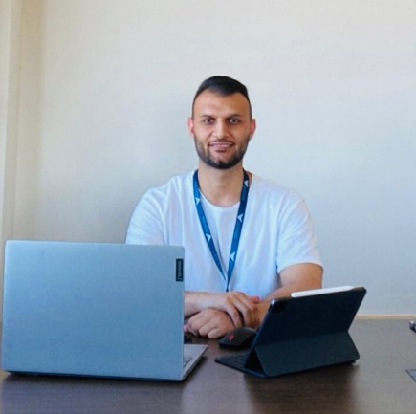
Feridun AYDINLI

Antalya Bilim University
Tourism Management

feridun.aydinli@antalya.edu.tr
B2-41

Education
Bachelor’s degree | Tourism Management | Selcuk University | 2015- 2019
Master | Tourism Management | Selcuk University | 2020- 2023
Doctorate | Tourism Management | Selcuk University | 2023-Continue

Work experience
Research Assistant | Antalya Bilim University/ Tourism Management | Sep. 2023- Continue

Publications

Articles
- Algan Özkök, G. & Aydınlı, F. (2022). A qualitative study about Konya Oven Kebab and general charactericts of a regional product. Journal of Gastronomy, Hospitality and Travel, 4(2), 83-94, https://doi.org/10.33083/joghat.2022.115.
- Aydınlı, F., & Bulut Solak, B. (2024). Evaluation of Atatürk Forest Farm Museum and Exhibition Hall in terms of Gastronomy Museums in Turkey. Aydın Gastronomy, 8(1), 43-64. https://doi.org/10.17932/IAU.GASTRONOMY.2017.016/gastronomy_v08i1004.
- Aydınlı, F., & Akgöz, E. (2024). Attitudes and motivations towards technology addiction and digital detox tourism: an evaluation by tourism academics. Journal of Selcuk University Vocational School of Social Sciences, 27(1), 357-370. https://doi.org/10.29249/selcuksbmyd.1453630.
Book chapters
- Bulut Solak, B. Aydınlı, F. & Amin, S. B. (2023). Food and beverage operations and safety: the global scenario. Eds. H. Sezerel, & B. Christiansen, In handbook of research on sustainable tourism and hotel operations in global hypercompetition, (pp. 451-474). IGI Global. https://doi.org/10.4018/978-1-6684-4645-4.ch021.
- Bulut Solak, B. & Aydınlı , F. (2023). Assessing food safety and food waste relatively among food handlers practices in developing countries. Eds. Ş. Aydın, E. Özgül Katlav, K. Çamlıca, & F. Yönet Eren, In call for chapters: impactful technologies transforming the food industry, (pp. 196-213). IGI Global. https://doi.org/10.4018/978-1-6684-9094-5.ch013.
- Aydınlı, F. & Bulut Solak, B. (2023). Service personnel and food safety in hotel establishments. Eds. O. Çelen, & A. Ünal in, Tourism and Destination Research-III. (s. 233-256), Paradigma Academy Publications, Çanakkale.
Conference and Presentations
- Algan Özkök, G. & Aydınlı, F. (2021). Preliminary study on Konya Furun Kebab. III. International Sustainable Tourism Congress (pp. 449-456). Bingöl University-Ordu University. Bingöl-Ordu.
- Aydınlı, F. & Bulut Solak, B. (2022). Food and beverage operations and safety in hospitality industry during and after the Covid-19 outbreak: the Turkey scenario. 1st International Congress on Modern Sciences (pp. 1083-1097). Tashkent Chemical-Technological Institute. Tashkent.
- Aydınlı, F., Bulut Solak, B., Ertaş, M., Avcı, H. & Kurnaz, A. (2023). Investigation on the status of local cheeses of Konya in gastronomy tourism and the reasons for consumers’ preferences. International Conference "The Future of Tourism - Innovation and Sustainability" within the IV MILLENIALS' TOURISM FEST. Management Development Institute of Singapore in Tashkent. Tashkent.

Projects
Master's Thesis Project titled "Food Safety Knowledge Levels of Service Personnel Working in 4- and 5-Star Hotel Businesses: The Case of Ankara", Co-executive Director.

Research areas
- Destination marketing
- Gastronomy tourism
- Food safety
Foreign languages
- Turkish Native

