Tunç Uluç
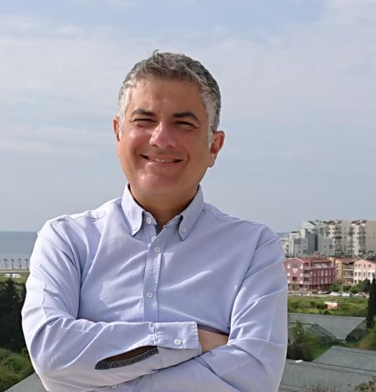
Prelector
Antalya Bilim University
Tourism Faculty

tunc.uluc@antalya.edu.tr
tunc@sarap.info

Education

- Bachelor Bilkent University, Business Administration, 1996
- Master Florida International University, Hospitality Management, 2002
- Doctorate Akdeniz University, Gastronomy and Culinary Arts - ongoing

Academic Employment

- Prelector at Akdeniz University, Faculty of Tourism, Gastronomy and Culinary Arts, 2015
- Prelector at Akdeniz University, Faculty of Tourism, Tourism Management, 2019
- Prelector at Antalya Bilim University, Faculty of Tourism, Gastronomy, 2021

Professional Employment
- Owner and CEO of Uluç Gayrimenkul Yatırım Ltd Şti

Courses/Teaching
- Antalya Bilim University, Gast 405 – World Cuisines
- Antalya Bilim University, Gast 498 – Beverage Culture

Memberships
- President of Antalya University Support Foundation
- President of Antalya Gastronomy Union Association

